**Clocking In/Out**

* Click the https://www.linq.com/Files/TK/Content/image3.gifbutton next to the appropriate Job.
* **Time Keeper**will ask you if you want to log off.

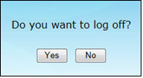

* Click **Yes** to exit **Time Keeper** or click **No** to continue working in **Time Keeper***.*
* Click the https://www.linq.com/Files/TK/Content/image2.gifbutton to clock out.  The **Clock Out** button will appear next to the Job that was clocked in, if there are multiple jobs.

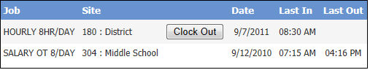

* Time Keeper will again ask you if you want to log off. Click **Yes** to exit **Time Keeper** or click **No** to continue working in **Time Keeper.**