**Check History**

This screen allows you to view any available checks.

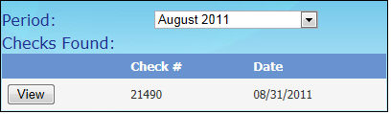

* Select a time period from the **Period** dropdown list. A list of checks for that period will display.
* Click **View** next to the **Check #** to display that check.
* The check will display as a PDF in Internet Explorer.

