**Requests**

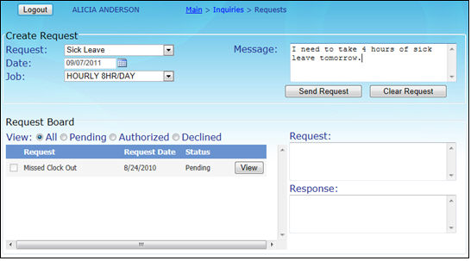

*CREATE REQUEST*

This is where you create and submit a request.

* Select the type of **Request** from the dropdown list.
* Enter a date in the **Date** field or select the date using the calendar.
* If you have multiple jobs, select the correct one from the **Job** dropdown list.
* Enter a message in the **Message** field, if necessary.
* Click **Send Request** to submit the request.
* Click **Clear Request** to delete the request by clearing the box.

*REQUEST BOARD*

This displays requests made by others, i.e. Administrator, *LINQ* software, etc.

* Select a **View** by clicking the appropriate button next to **All, Pending, Authorized** or **Declined.**
  + **All** is the default view but can be changed.
* Click **View** in the Request line to display the comments in the **Request** field.
* Enter a Response, if desired, in the **Response** field.