**Configure iPhone/iPad/iPod for Office 365**

1. Open **Settings**.
2. Select **Mail, Contacts, Calendars**, then select **Add Account** near the top of the right-hand column.  
   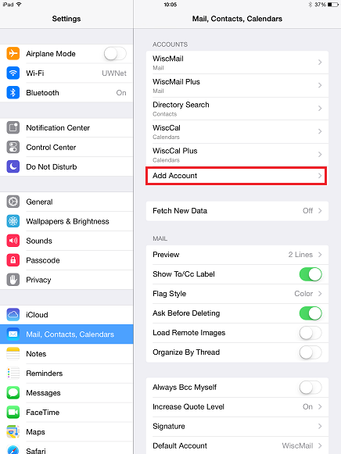
3. Select **Exchange**.  
   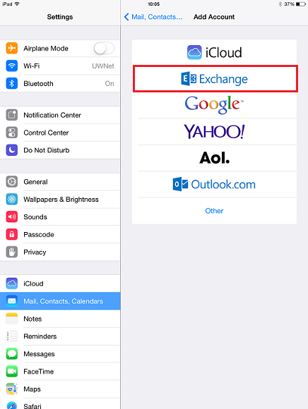
4. On the account setup window, enter the following for each field:

Enter the [primary address](http://kb.wisc.edu/31473) of your Service account which will take one of the following forms: ***name***@***scotland.k12.nc.us***

* + **Password:** Enter the password for the account being configured.
  + **Description:** Give the account any name you'd like, such as *Office 365*.

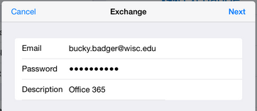

1. Select **Next**.
2. Enter the following information (Email and Description should have auto-filled with the previously supplied information):

* **Server:** outlook.office365.com
* **Username:**
  + [Email:](mailto:Email:) JDoe@scotland.k12.nc.us
* **Password:** Enter the password for your account being configured.

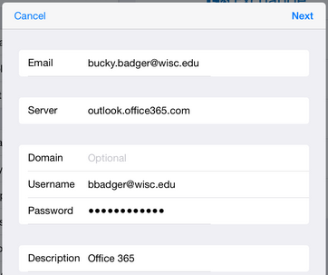

• Click **Done/Next**.

• You'll be directed to the enabled account applications page now. Choose what you'd like enabled. It is recommended that you enable all services.

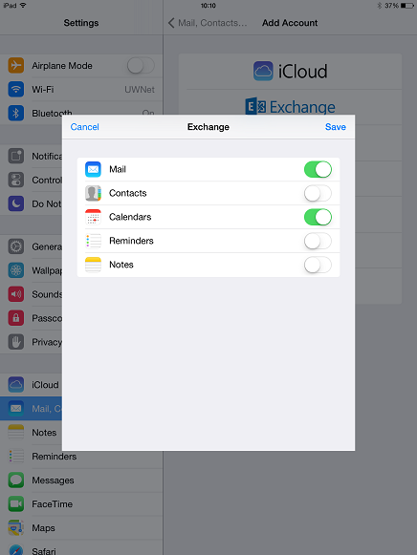

• Select **Save**.

• Select the new account from your list of accounts. It will be listed according to the description you chose for it.

• Select **Mail Days to Sync** and set it to **No Limit** if you would like all of the mail in your inbox to be synced to your device. The default time period is one week. **Note**: the more mail that is synced, the longer it may take to get all your messages on to the device.

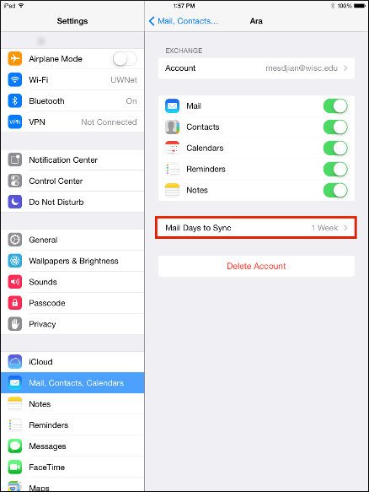

Setup is complete. Email and calendar data (if enabled) are available in the appropriate apps.