# PowerTeacher PRO

# End of Nine Weeks Verification for Report Card Grades

Elementary Schools

The grade verification process should be completed when all students are in the correct class, all grades are accurate, and there are no blank grades. This should only be completed for classes you assign grades to.

1. Select the current term (Q1, Q2, Q3, Q4, or F1) from the drop down screen.
2. Select a current class
3. Click on the A+ Grading charm.
4. Click on Comment Verification.

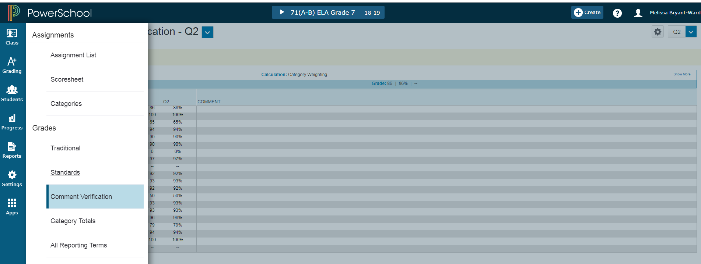

To Add Comments

1. Click on the Current Term (Q1, Q2, Q3, Q4, or F1) grades beside the student name. The Score Inspector shows on the right.
2. Click the Comment icon in the Score Inspector.
3. Click Show Comment Bank and select the + sign to add a comment. The comment will appear beside the student’s score cell. Click Save.
4. Comments must be added for the current term to show on the report card.

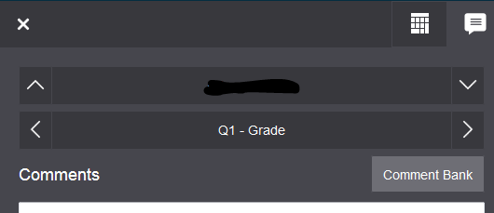

To save and verify grades/comments. Make sure student current term grades are correct for all students. At the bottom of the screen, click the final grade status button.

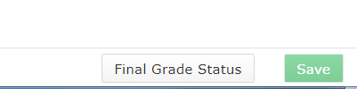

This screen will appear. Click the box that all current term grades are complete and place a comment in the box that all term grades are verified and correct with the date. Save.

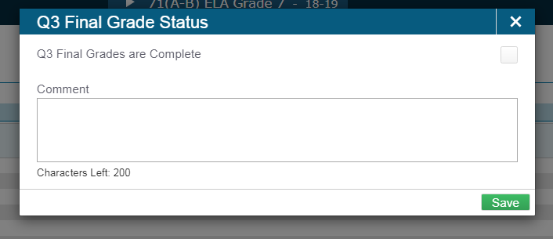

With the Comment Verification page showing, click **Ctrl-P** and send to the printer of your choice. **Repeat ALL steps for each class with grades.**

Sign and date all the print outs.

**Turn in the signed pages by the due date set by your principal/data manager.**

Important Reminder: At the end of each school year, THIS PROCESS MUST BE COMPLETE FOR F1. After you verify Quarter 4 grades, complete steps for F1.