How To Set The Copiers Up On Your Computer

1. Press the windows key  and the r key at the same time.

2. The Run window opens 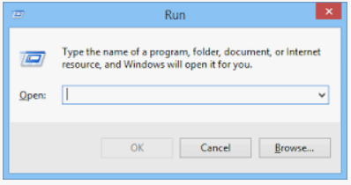

3. In the open field in the run window type [\\scs-printerserv\](file:///\\scs-printerserv\)

4. This window or one similar will open up 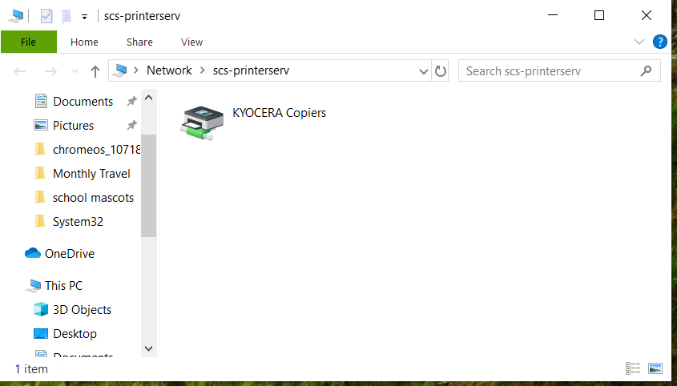

5. Right click on Kyocera copiers and then left click connect

6. When you do that a window pops up: download, installing, etc. Once that window goes away the copiers will be installed. It may go away very quickly, may not even see it.