# PowerTeacher PRO

**SEMESTER CLASSES**

# High School: End of Nine Weeks/Semester:Final Grade Verification for Report Card Grades

The grade verification process should be completed when all students are in the correct class, all grades are accurate, and there are no blank grades. This should only be completed for classes you assign grades to.

1. Select the current term (Q1, Q2, Q3, Q4)
2. Select a current class.
3. Click on the A+ Grading charm.
4. Click on Comment Verification.
5. Make sure that you are working with the current term grades

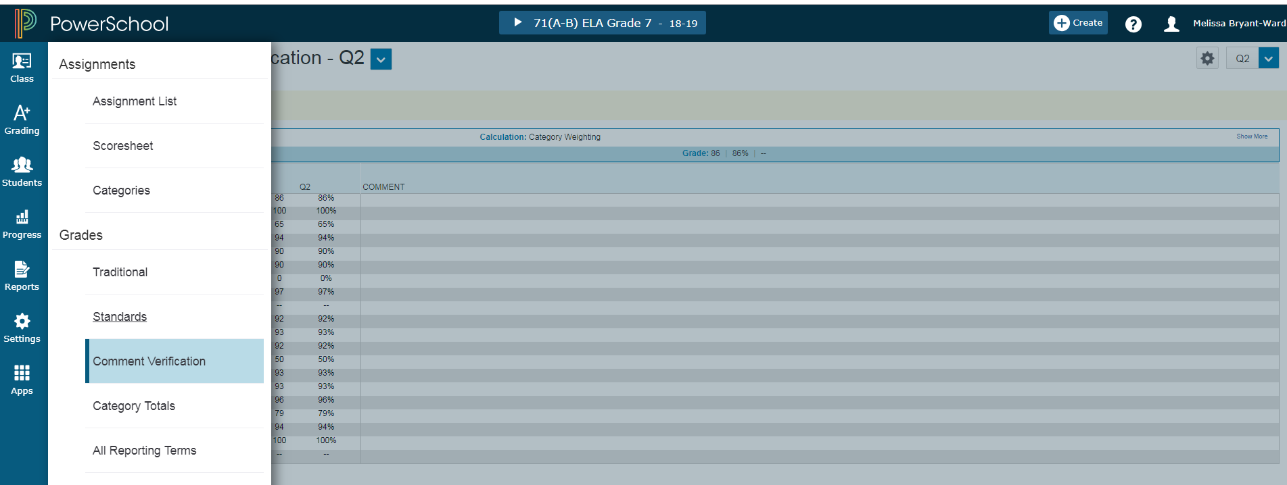

To Add Comments

1. Click on the current term (Q1, Q2, Q3, or Q4)grade beside the student name. The Score Inspector shows on the right.
2. Click the Comment icon in the Score Inspector.
3. Click Comment Bank and Show Comment Bank. Select the + button to display comment. A blue Comment icon appears in the student’s score cell. Click Save. You can click on the icon to read the comment.
4. Comments must be added for the current term grade in order for them to show on the report card.

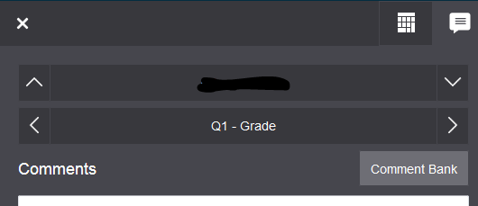

To save and verify grades/comments. Make sure student current term grades are correct. At the bottom of the screen, click the final grade status button.



This screen will appear. Click the box that all current term grades are complete and place a comment in the box that all term grades are verified and correct with the date verified. Save.

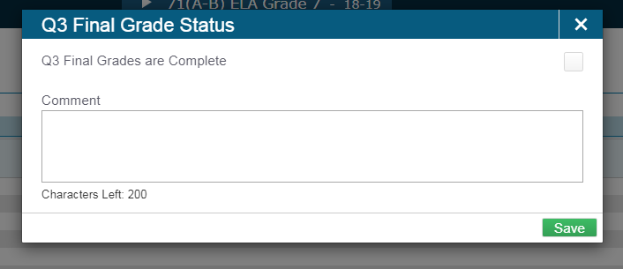

Print the comment verification screen. With the Comment Verification screen showing, click **Ctrl-P** and send to the printer of your choice. **Repeat ALL of these steps for each of your classes with grades.**

**Sign, date, and turn in the signed pages by the due date set by your principal/data manager.**

**Note: At the end of each semester, since grades will be final, you must complete this process for the quarter and the final grade. For example, when you complete Q2, you must also verify X1 and F1. And, when you complete Q4, you must verify X2, and F1.**

Enter the X1 (Exam) grades for each class.

1. Switch to the X1 reporting period.
2. Click on the dash beside the first student’s name under the X1 column. The score inspector shows on the right hand side of the screen.
3. Enter the grade and the percent for each student.
4. If a student is exempt from the exam, average the Q1 and Q2 grade, and enter that grade for the exam grade. (It should be the same as your F1 calculated grade.)

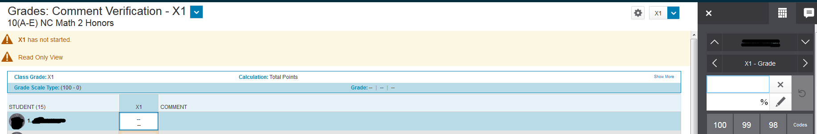

Enter the X1 grades for each class with grades.

Verify the F1 (Final) grades for each class and Print the All Reporting Terms Screen

1. Switch to the F1 reporting period.
2. Click on the A+ Grading charm.
3. Click on All Reporting Terms.
4. You will see the two nine-week term grades, the exam grades and the calculated final grades.
5. If you need to change a final grade, click on the grade under the F1 column and change the number grade and the percent grade in the score inspector.
6. Print the screen after verifying the final grades. Use **Ctrl-P** and send to the printer of your choice.

Sign and date all the print outs. Turn in to data manager.